Pifco Lamp Conversion

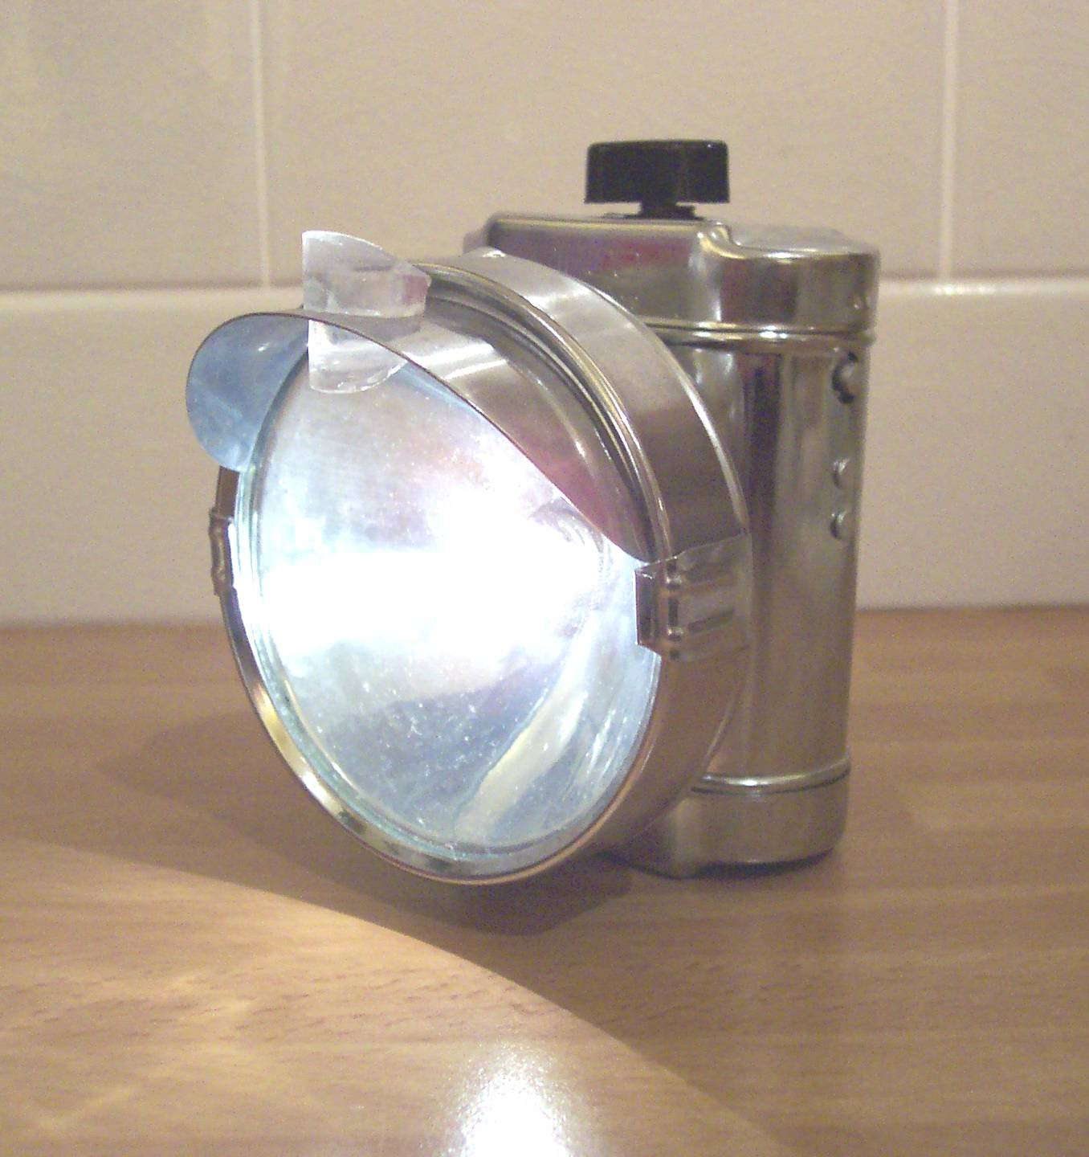

By
Paul Costin

Pifco Lamp conversion

Introduction

The chrome lamp generally made by Pifco during the 1970’s, used batteries, which are now no longer available.

Apparently a converter was introduced to allow the use of more modern battery types. However, I have only ever seen one of these and they do not appear to be generally available nowadays. As a collector of Raleigh Choppers I had purchased a number of these chrome lamps to finish off my restorations, but found it infuriating that I could not get them to work! I decided to find a modern alternative, which I could use to convert the lamps. Finally, with readily available parts, a drill, hacksaw and superglue, an hour or so of work, I was able to successfully convert the lamps and use modern batteries. This is a pictorial guide on how to do such a conversion. It depicts the conversion of a Pifco lamp, but the theory works equally as well with the smaller silver painted Ever-Ready or Exide Lamps.

Parts required
The electric components I used for this I purchased from Maplin Electronics.
You will need;
One 2c battery box suitable for 2x LR14 1.5 volt batteries
One 2.5v 3a screw bulb (To replace the Pifco lamp bulb)
One PP3 Clip to connect battery pack to wires
One M4 bolt (with Phillips rounded head) and 2 nuts
A toothpaste tube cap about 5-8mm in length
One spade connector
Some foam or bubble wrap

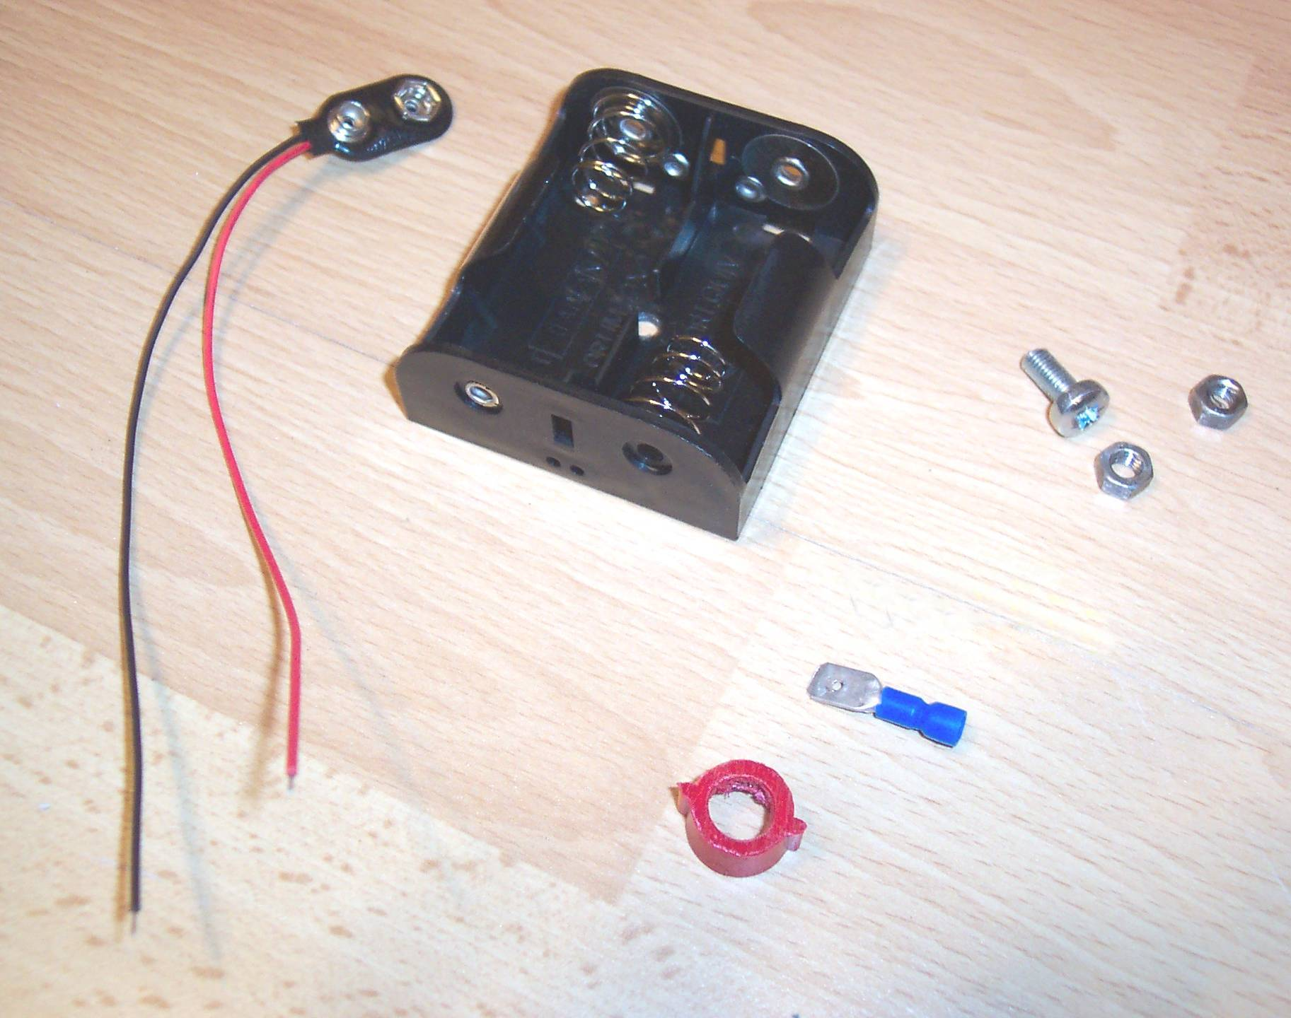

Step 1
Ensure that the M4 bolt is cut down to about 5/8 inch and screw one of the nuts fully on to it. (This will act as a guide. It has to be set into the battery holder and protrude 8mm maximum from it)
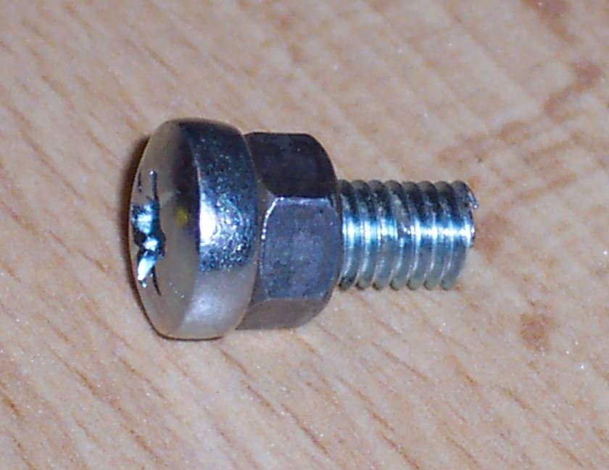

Step 2
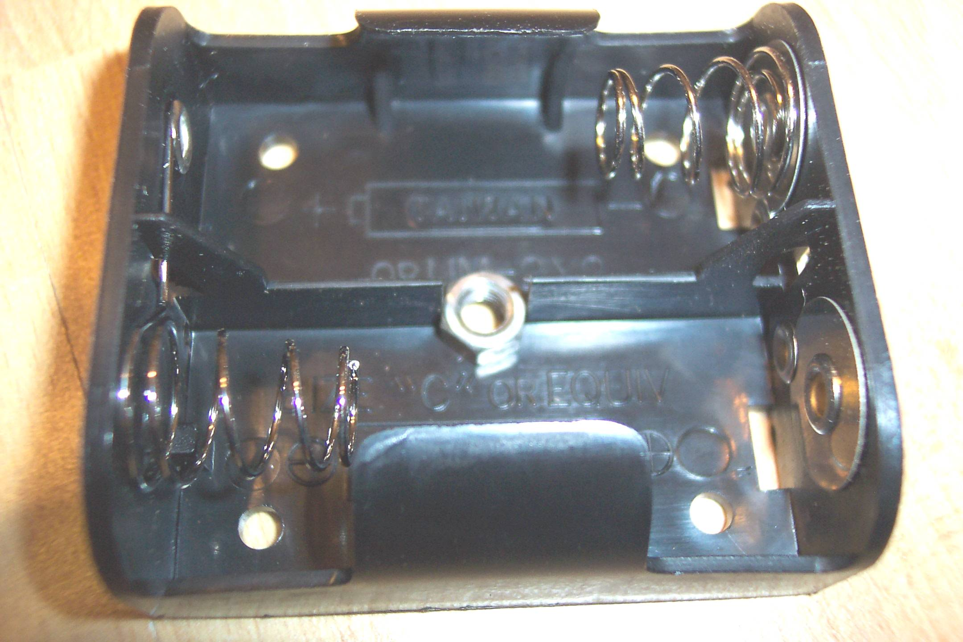
Place the other nut into the centre of the battery box, as illustrated. It may be necessary to enlarge the hole slightly to allow for the M4 bolt.

Step 3
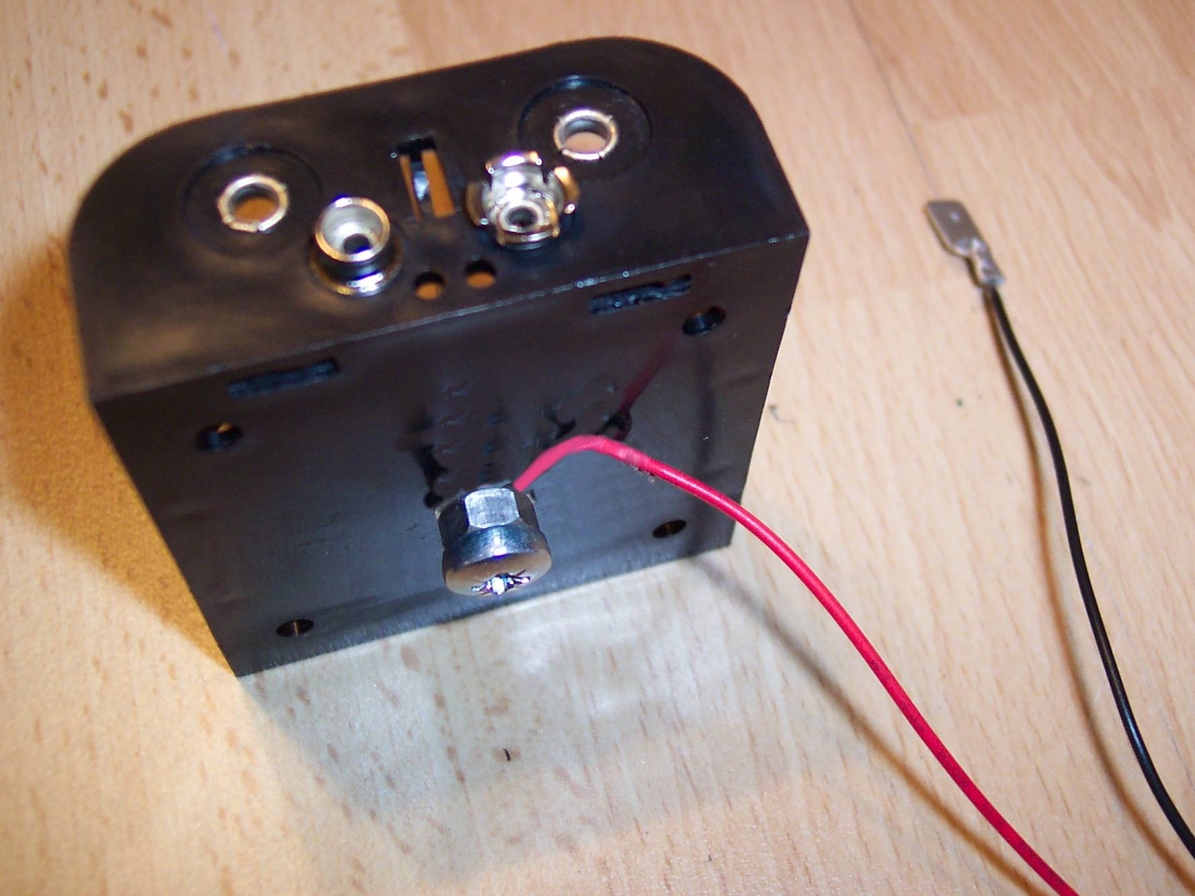

Connect the red wire from the PP3 clip to the bolt, by wrapping it round several times, then place the bolt through the hole in the battery box, connecting it to the nut on the other side and tighten.

Step 4

Now for the slightly fiddly bit! Using a toothpaste tube cap or similar plastic item (I used a kitchen sealant tube cap) I cut it down so that it was about ¼ inch or 5mm in length. After this I cut into one side of it in the middle so that I could push the spade clip into it. Ideally a hacksaw should be used for this purpose to allow a nice tight fit when the clip is pushed into it.
Having ensured that the clip fits snugly, connect the black wire to it.

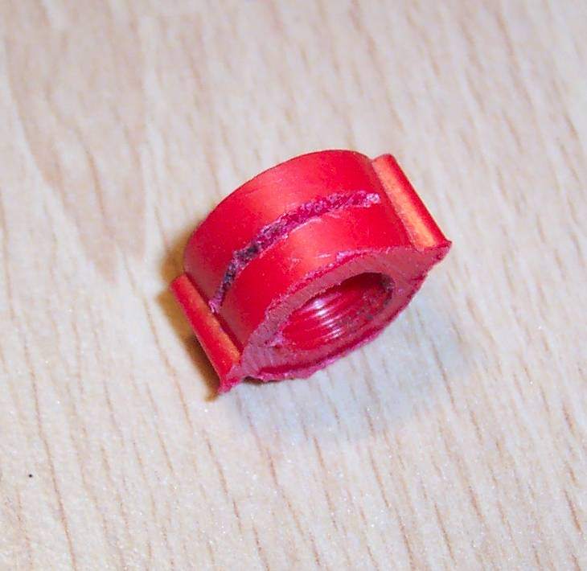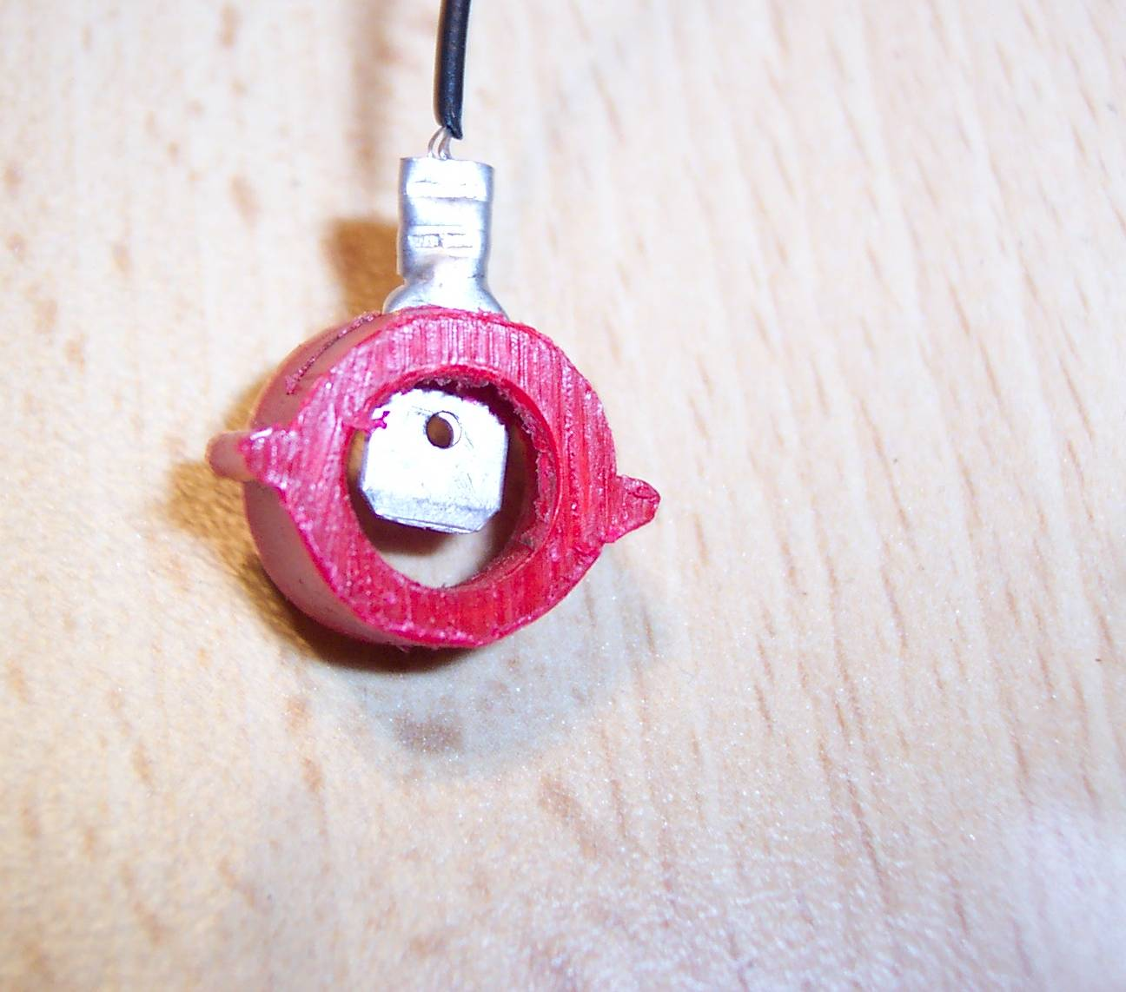

Step 5
The next step is to superglue the plastic cap onto the red plastic underside of the Pifco lamp lid. The idea is this, when the black “switch” on the lid is rotated clockwise, it goes down and makes contact with the spade clip, thus completing the circuit (see over).
The reason why the toothpaste tube cap needs to be no longer that 5 mm is that if it were any longer there is a likely hood that the lamp lid would not fit properly down as it would hit the top of the battery holder.

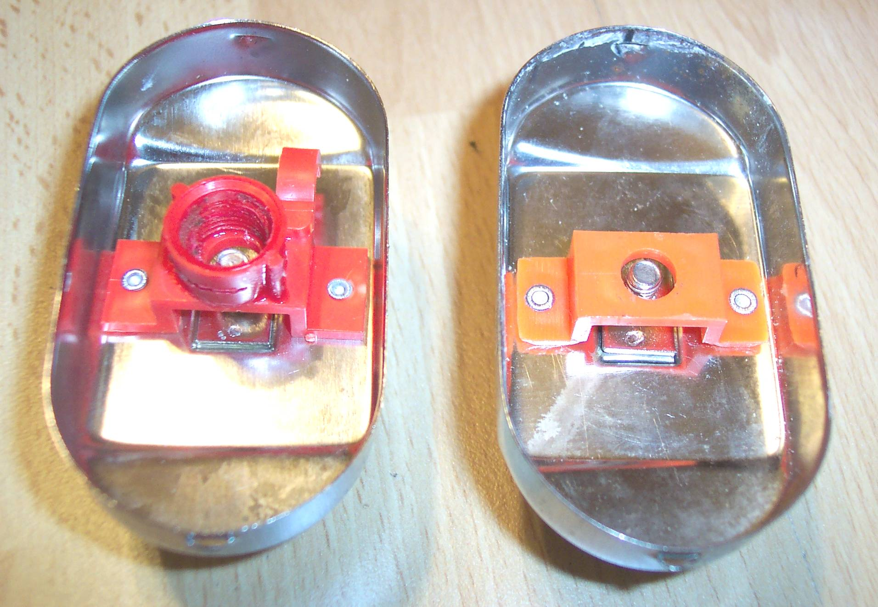
Try to ensure that the toothpaste cap or similar item is affixed with the small saw cut (for the spade clip) positioned as depicted on the above illustration
And the one below
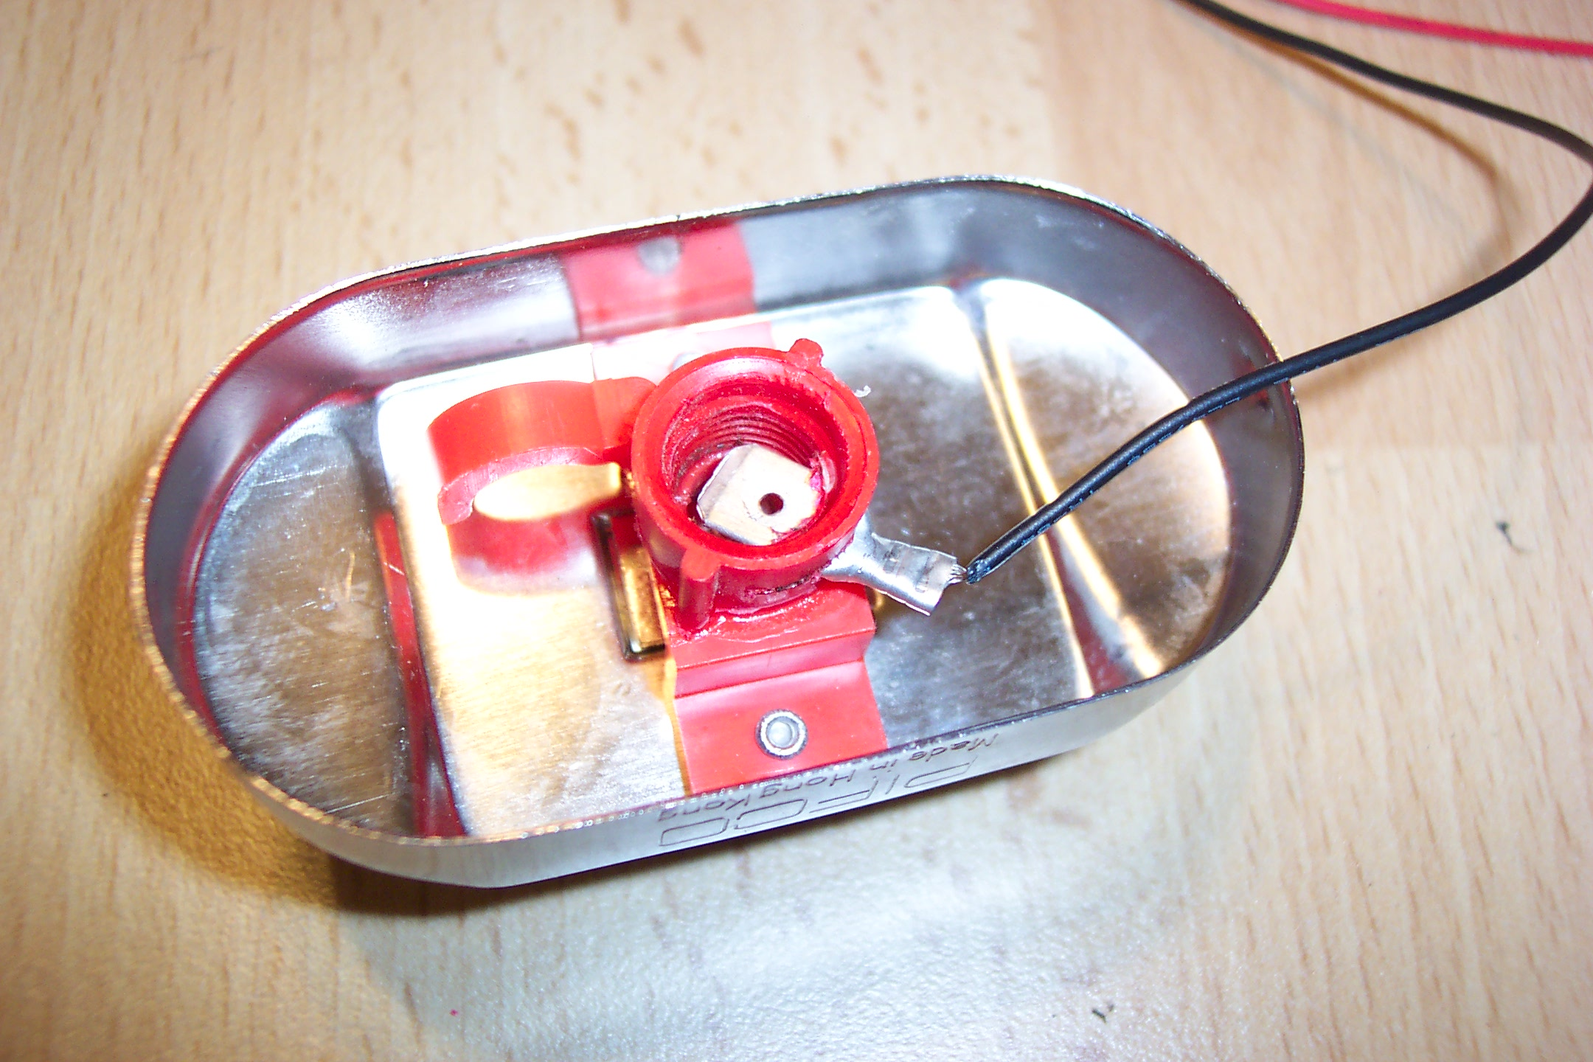

Step 6
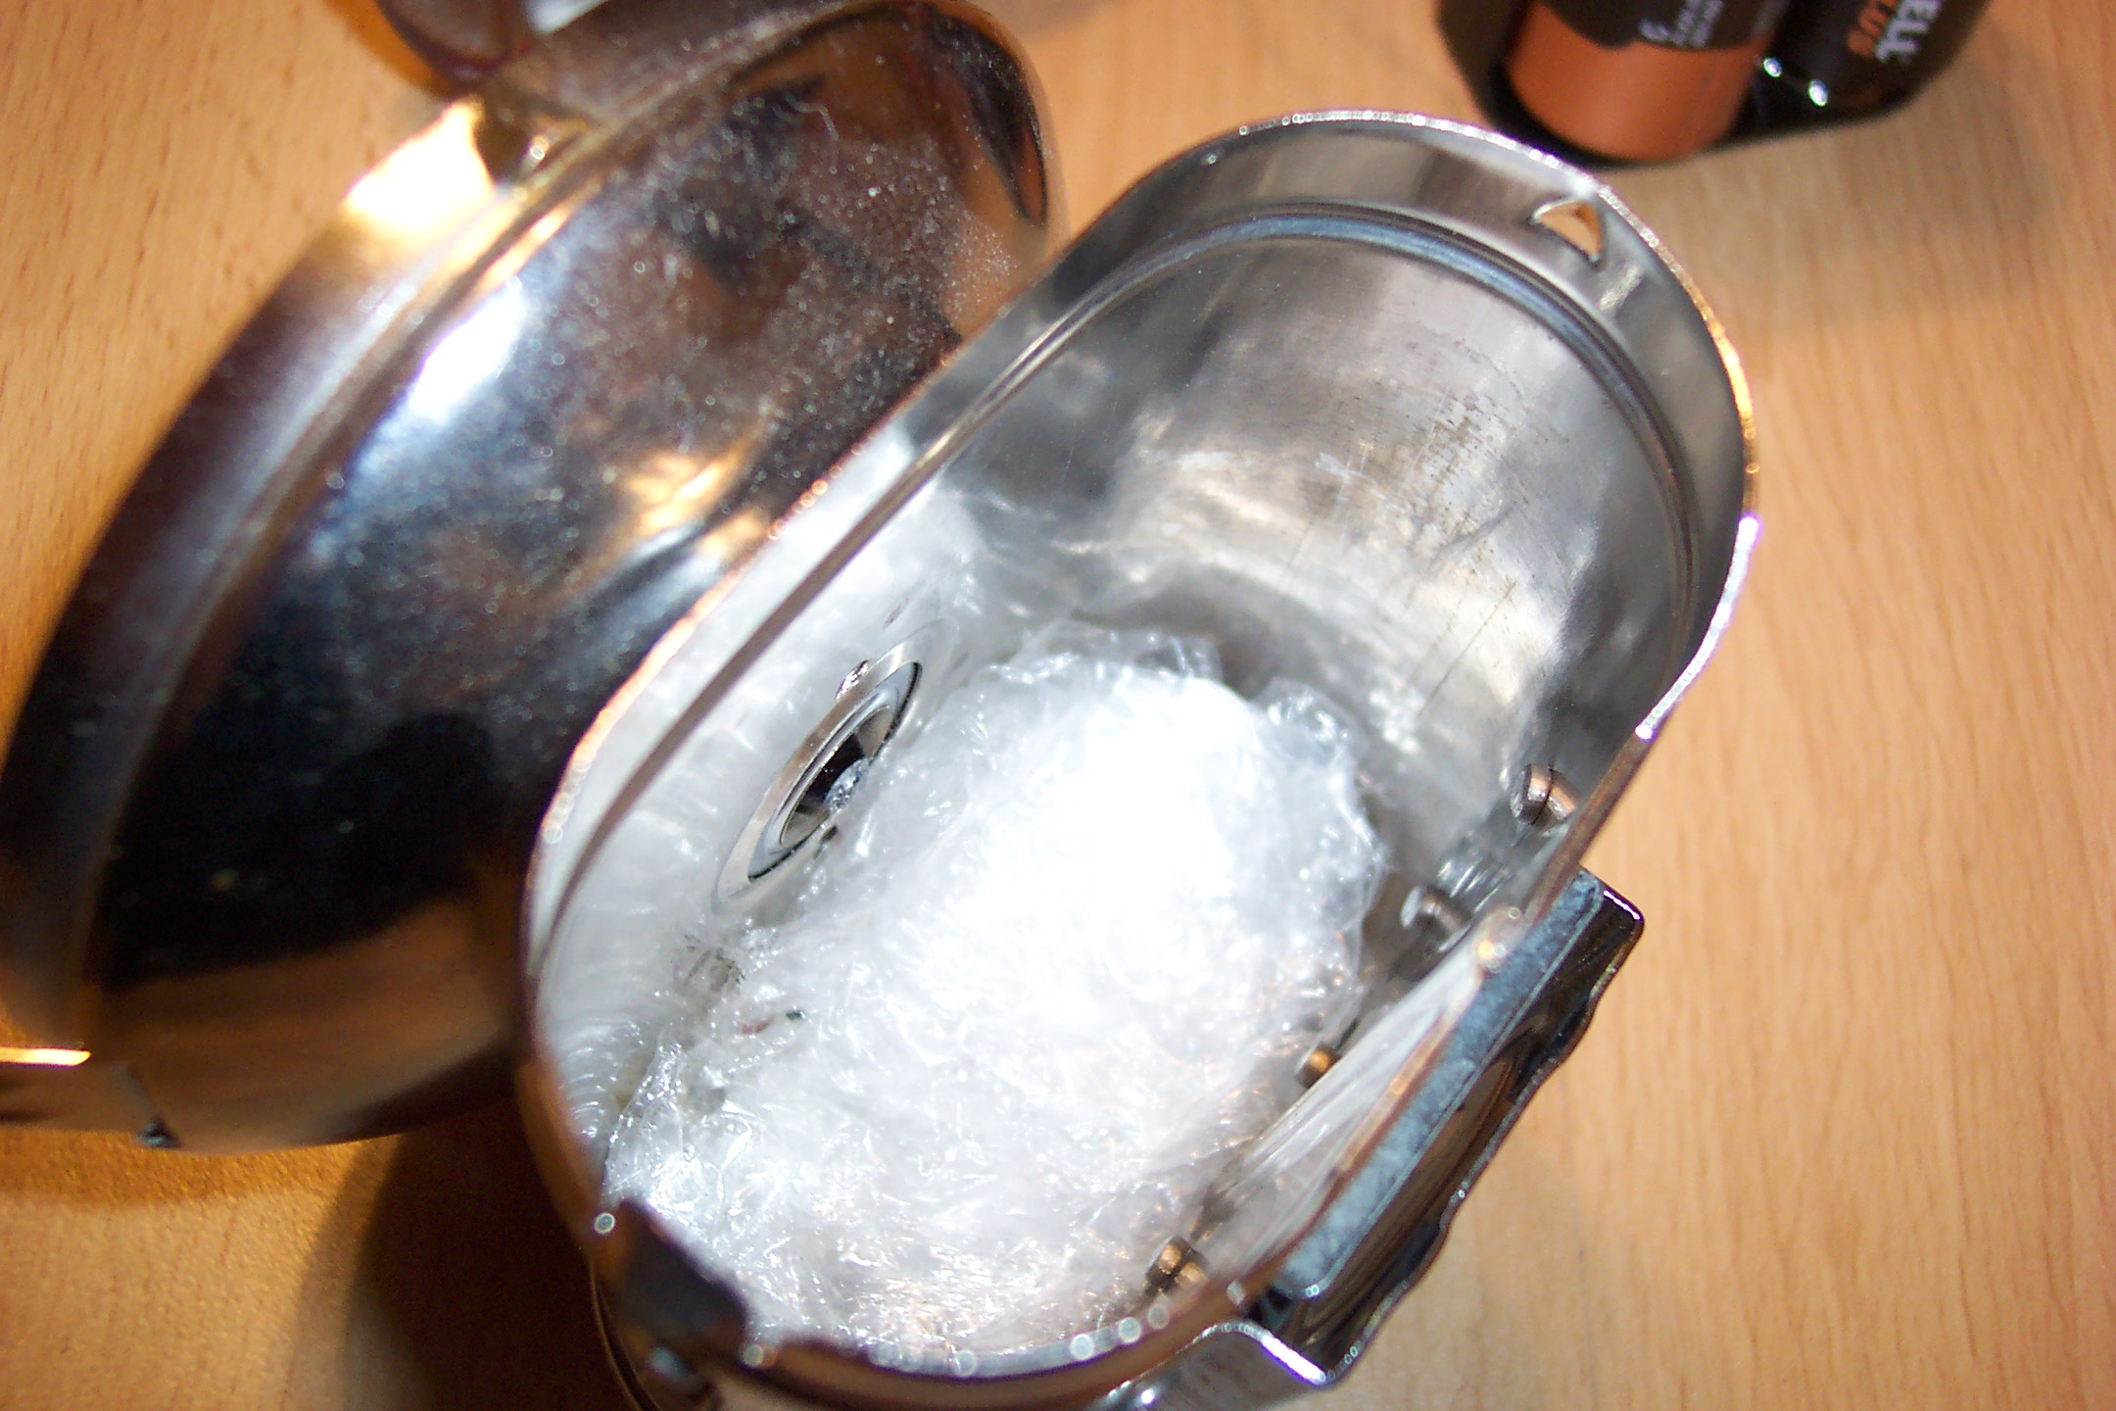
The battery holder is much smaller than the pifco lamp holder and therefore a piece of foam or bubblewrap needs to placed into the base of the lamp. It also serves another purpose, because when the battery holder is placed into the lamp it needs to be placed precisely. The Phillips bolt needs to align exactly where the 2.5 Volt bulb screws through the lamp casing. (See below)
The quantity of bubble wrap needed is a bit of trial and error!
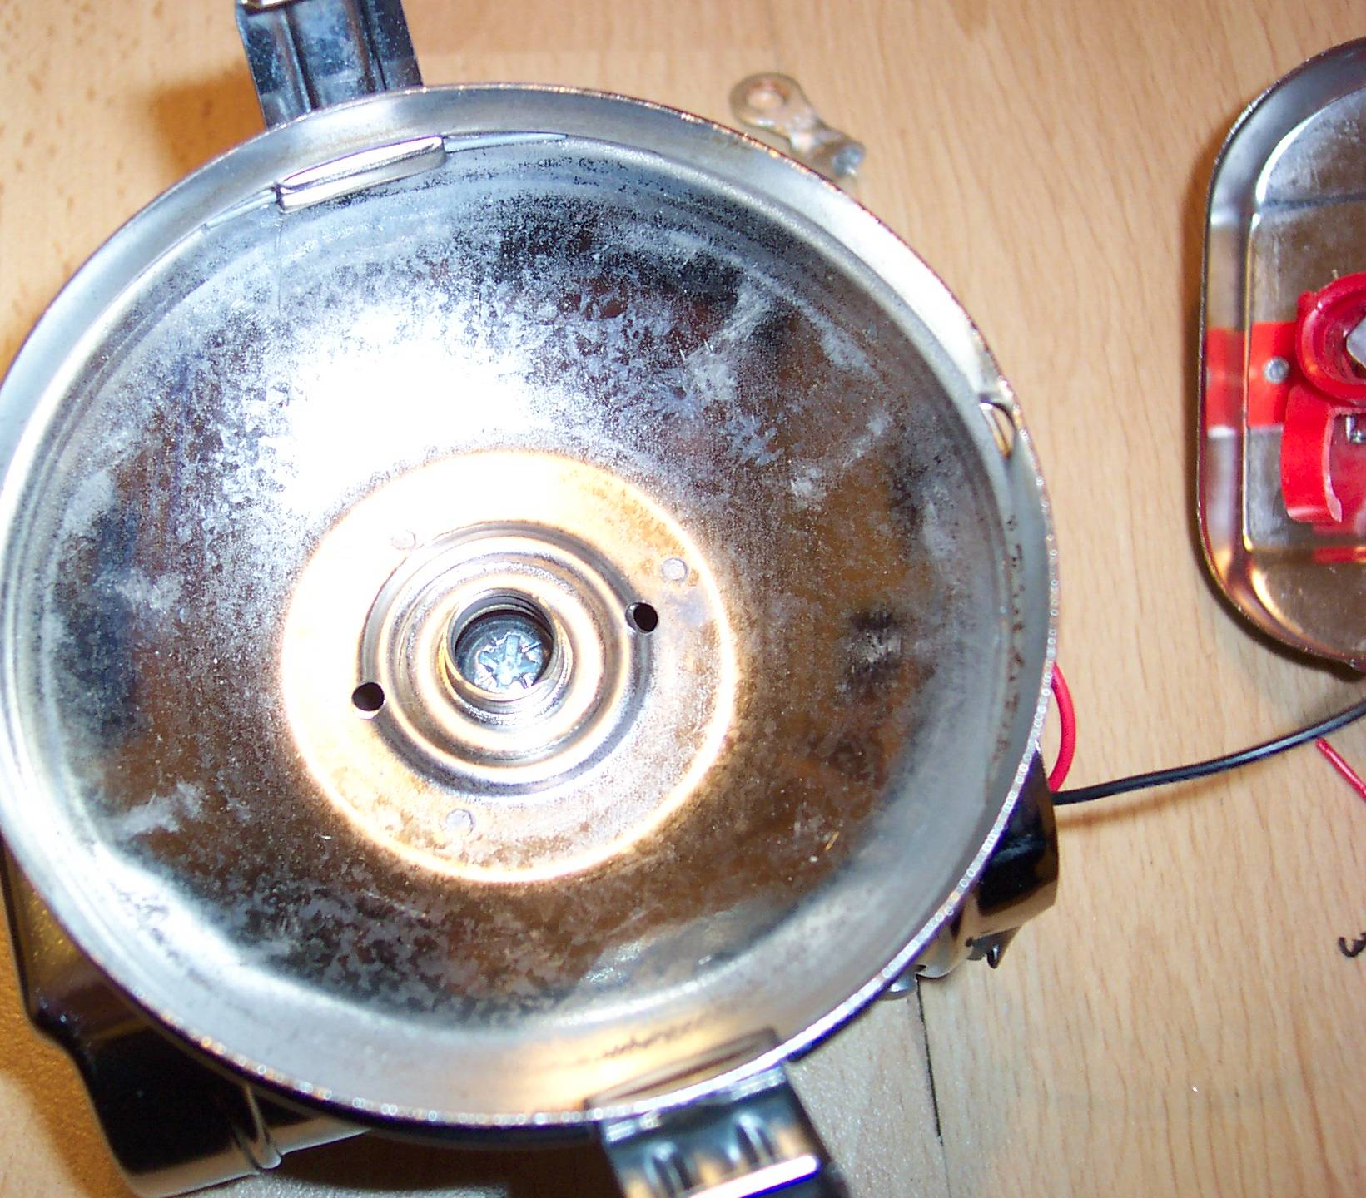
Step 8
Once the bolt is aligned with the bulb hole and it is ensured that there is sufficient packing under the battery holder to stop too much movement, the 2.5-volt bulb should be screwed down so that it meets the Phillips bolt centrally. This also assists in retaining the battery holder firmly.
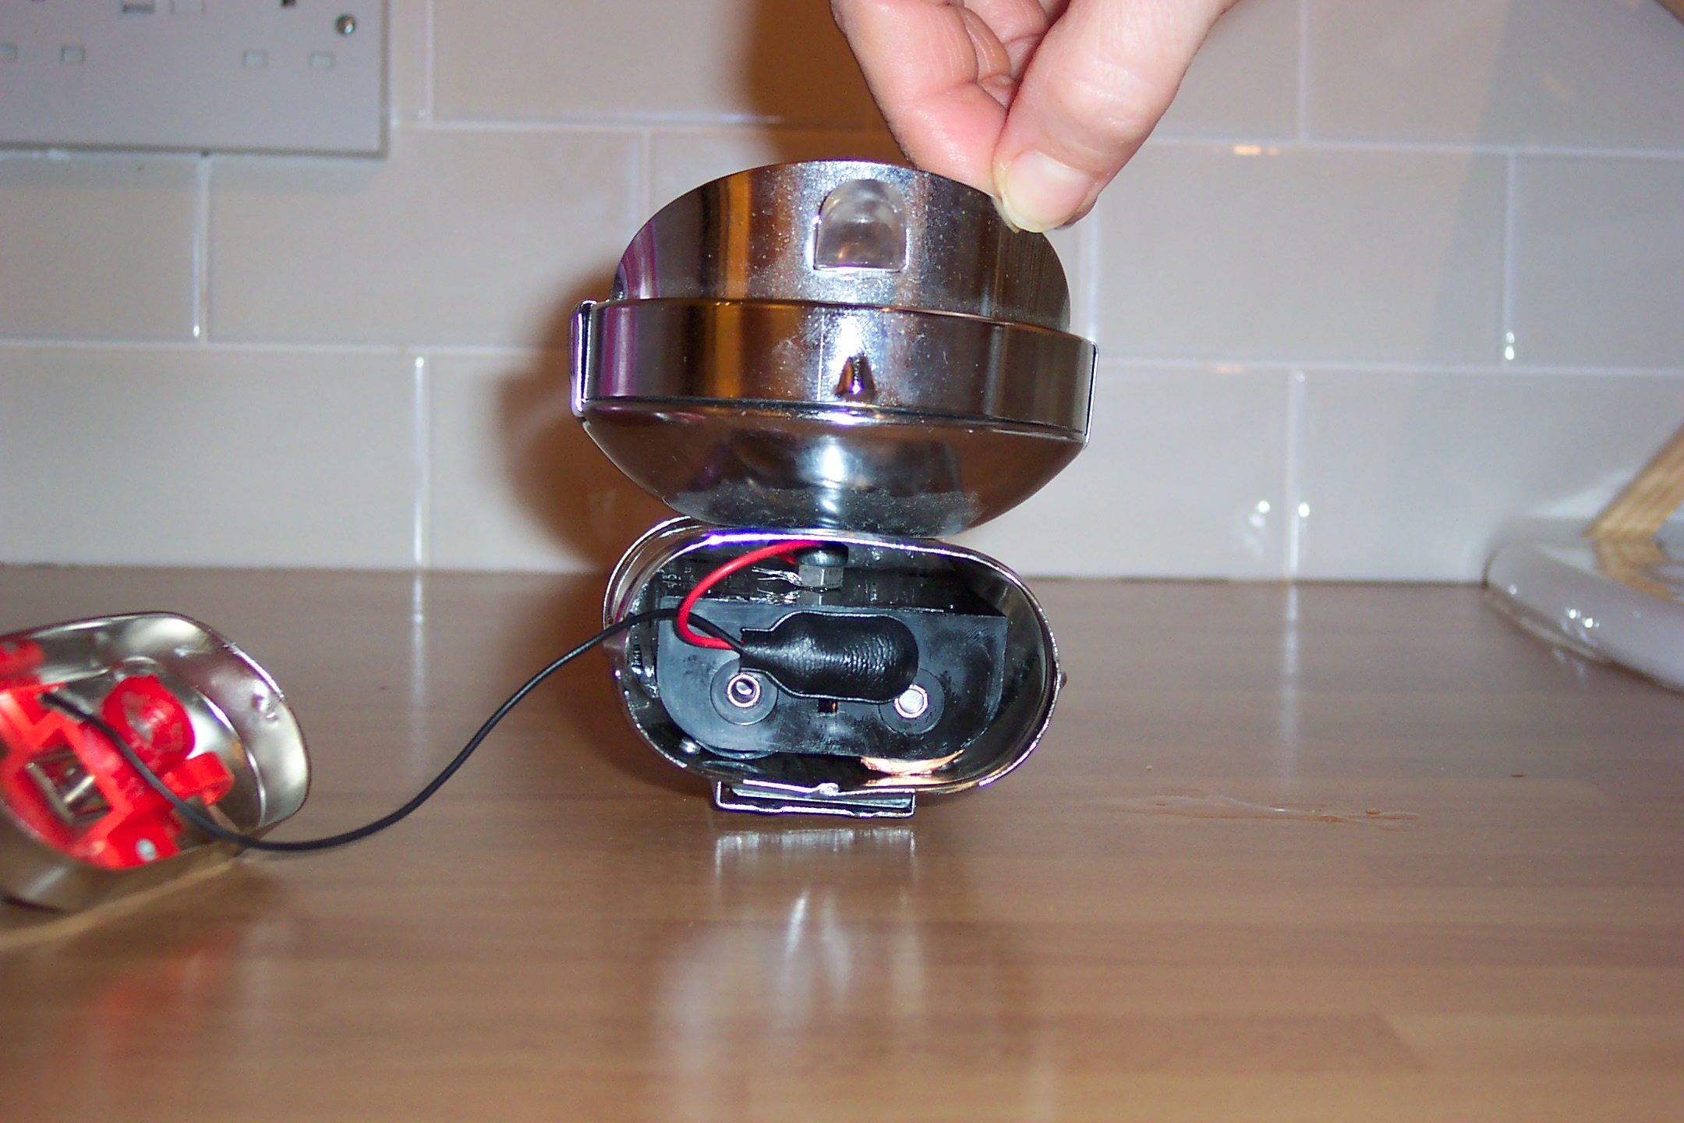

The illustration above shows the position of the battery holder within the lamp.
The lense cap can now be refitted and the lamp re-
assembled.

Conclusion
I have had 100 % success with this conversion; it has been designed in such a way that the only adaptation to the Pifco lamp is the toothpaste cap being super glued to the lamp lid.

The quality of illumination appears to have been unaffected in any way .

I would welcome any feedback, regarding improvement of this design.

Paul Costin
January 2004

